Hands-on Assignments:

Assignment#1. Create a VM and install docker and test the images inside the container with the commands

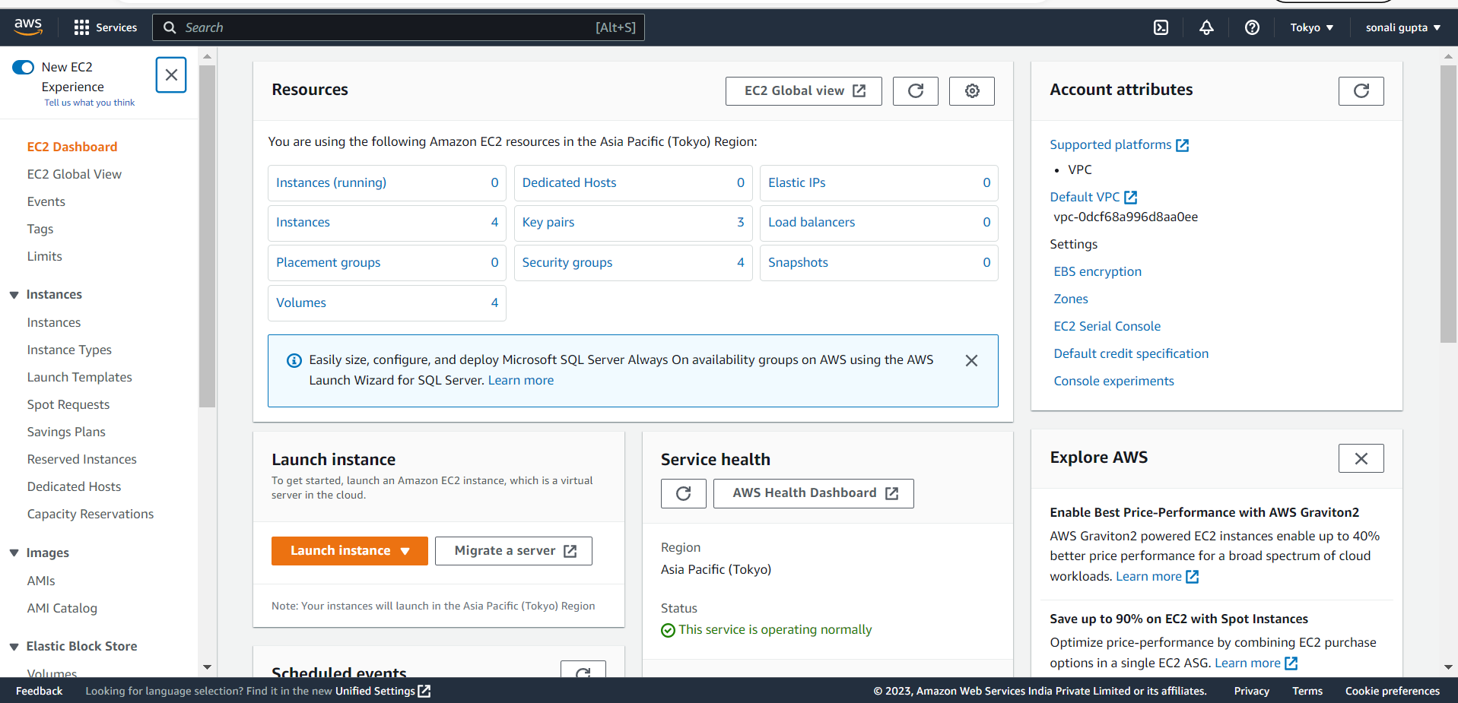

Launching an instance

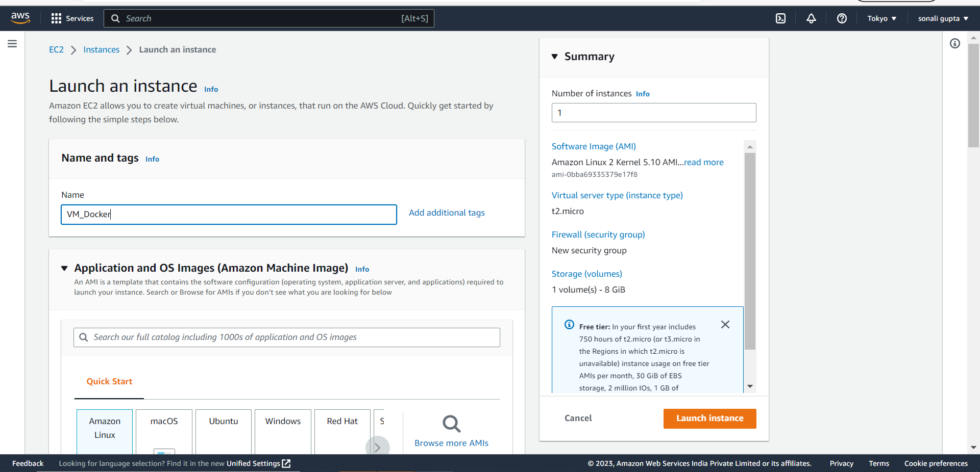

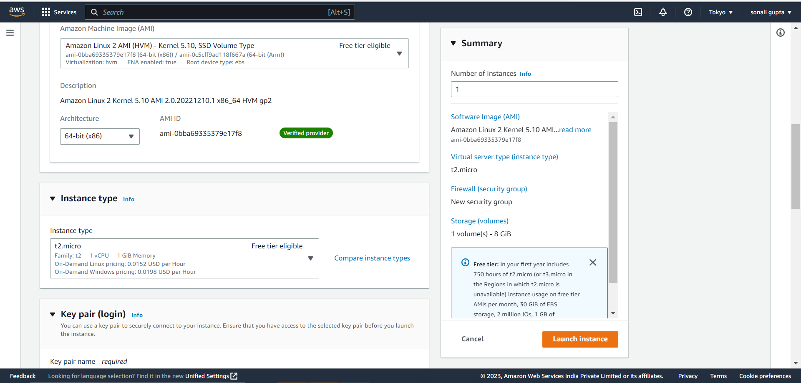

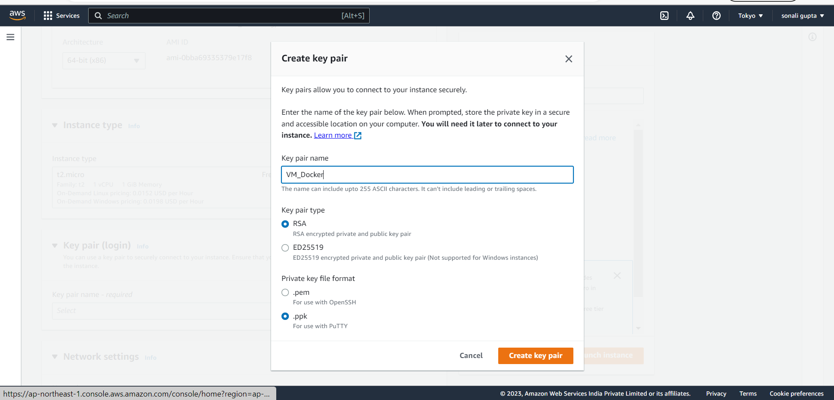

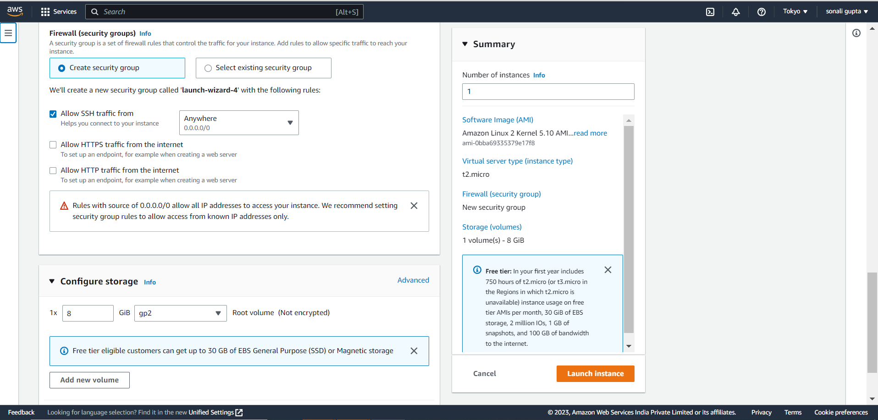

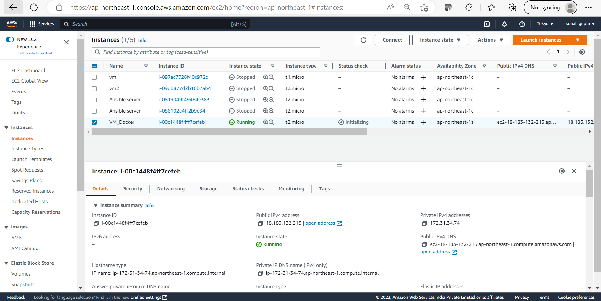

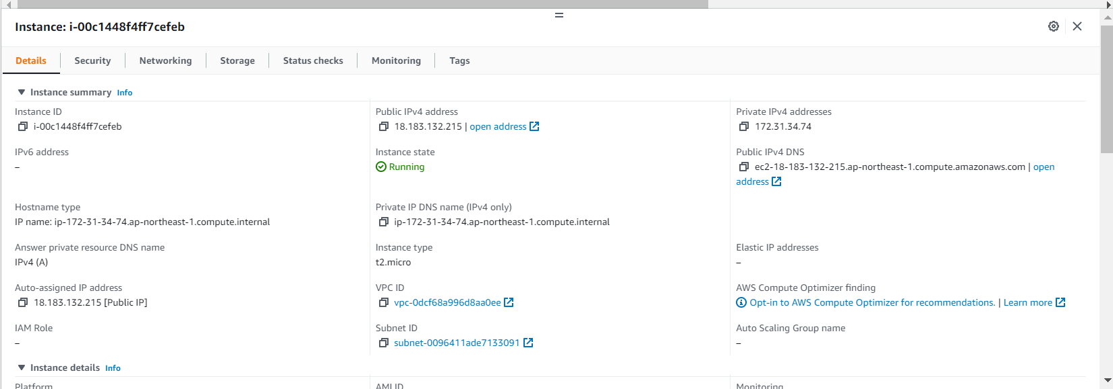

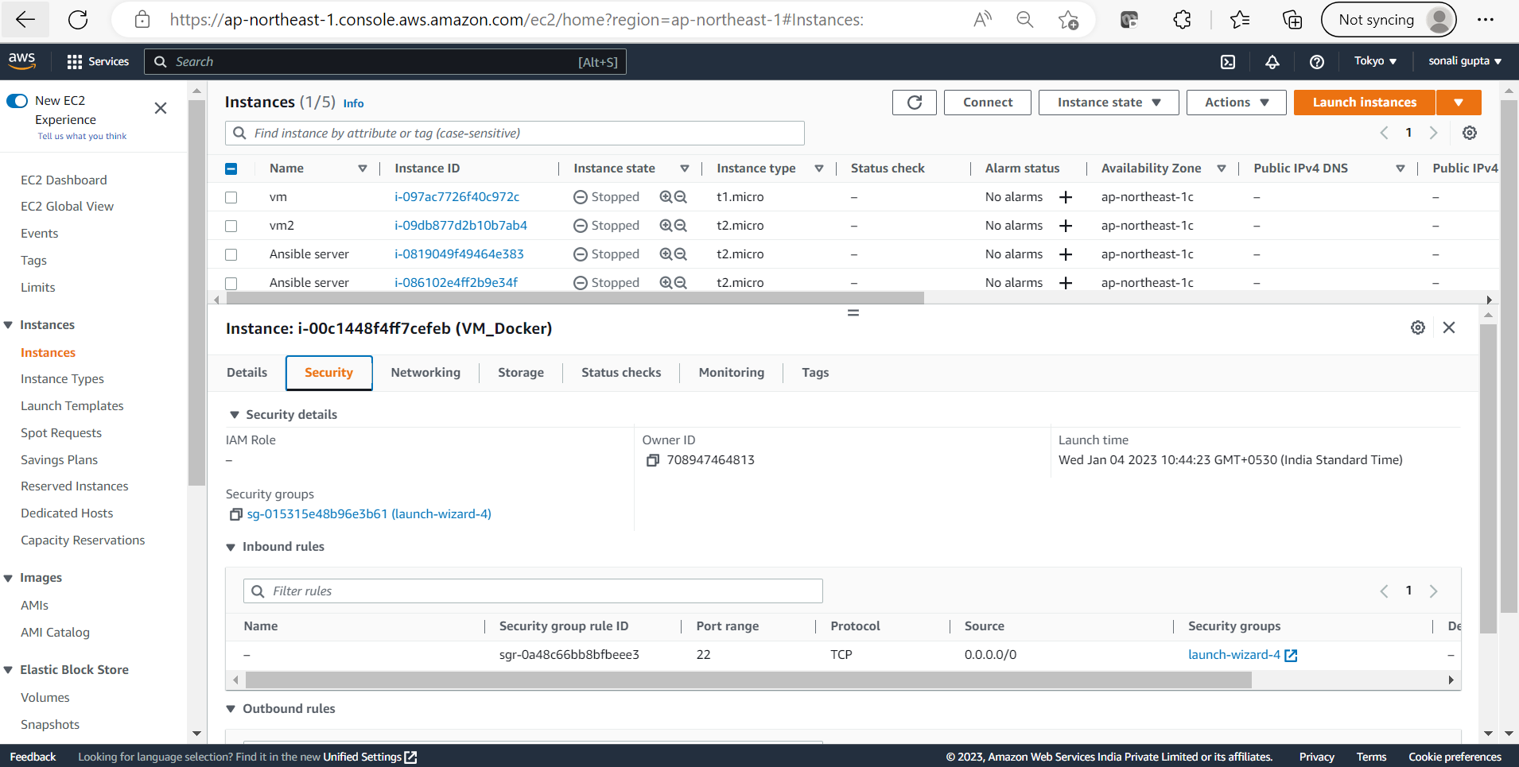

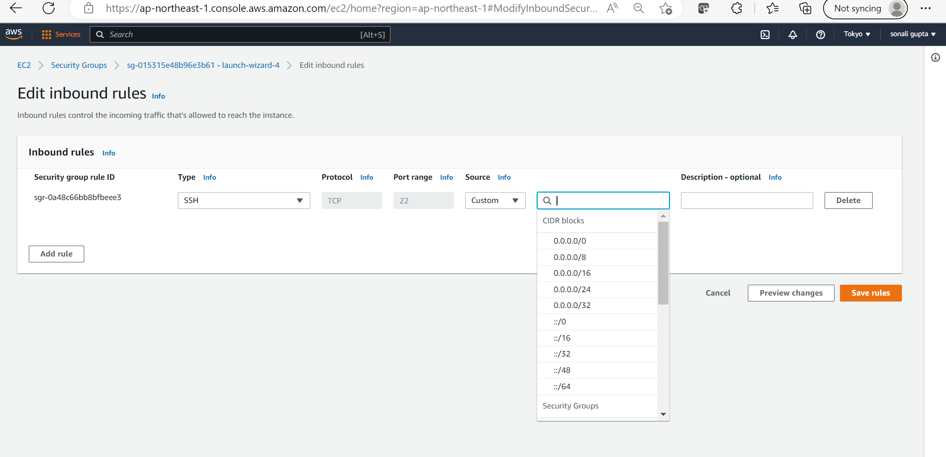

**sudo amazon-linux-extras install docker**

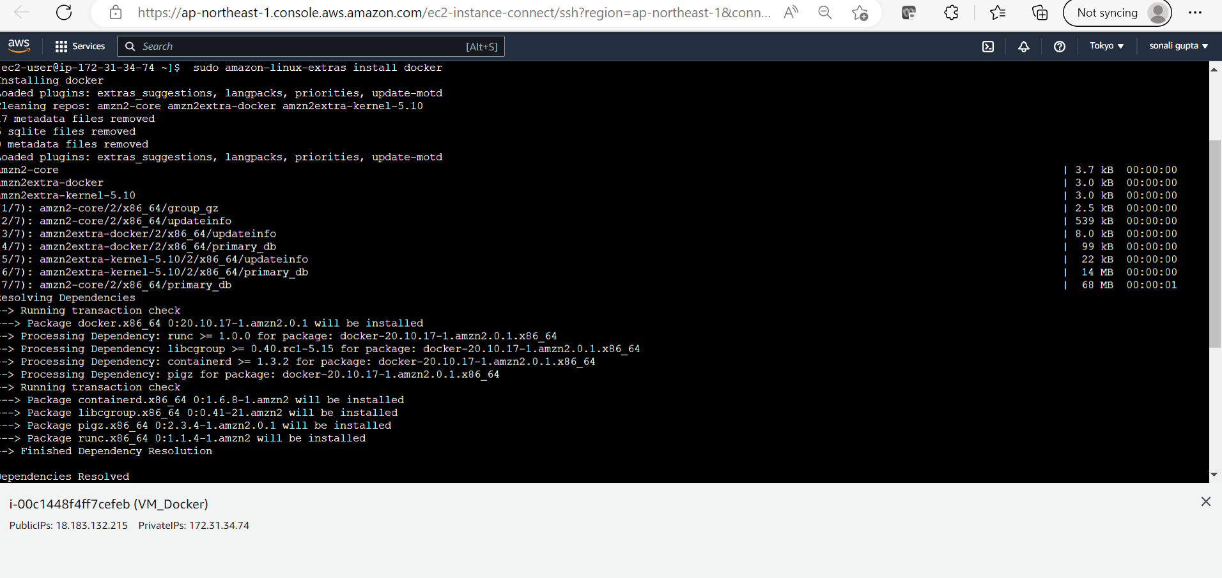

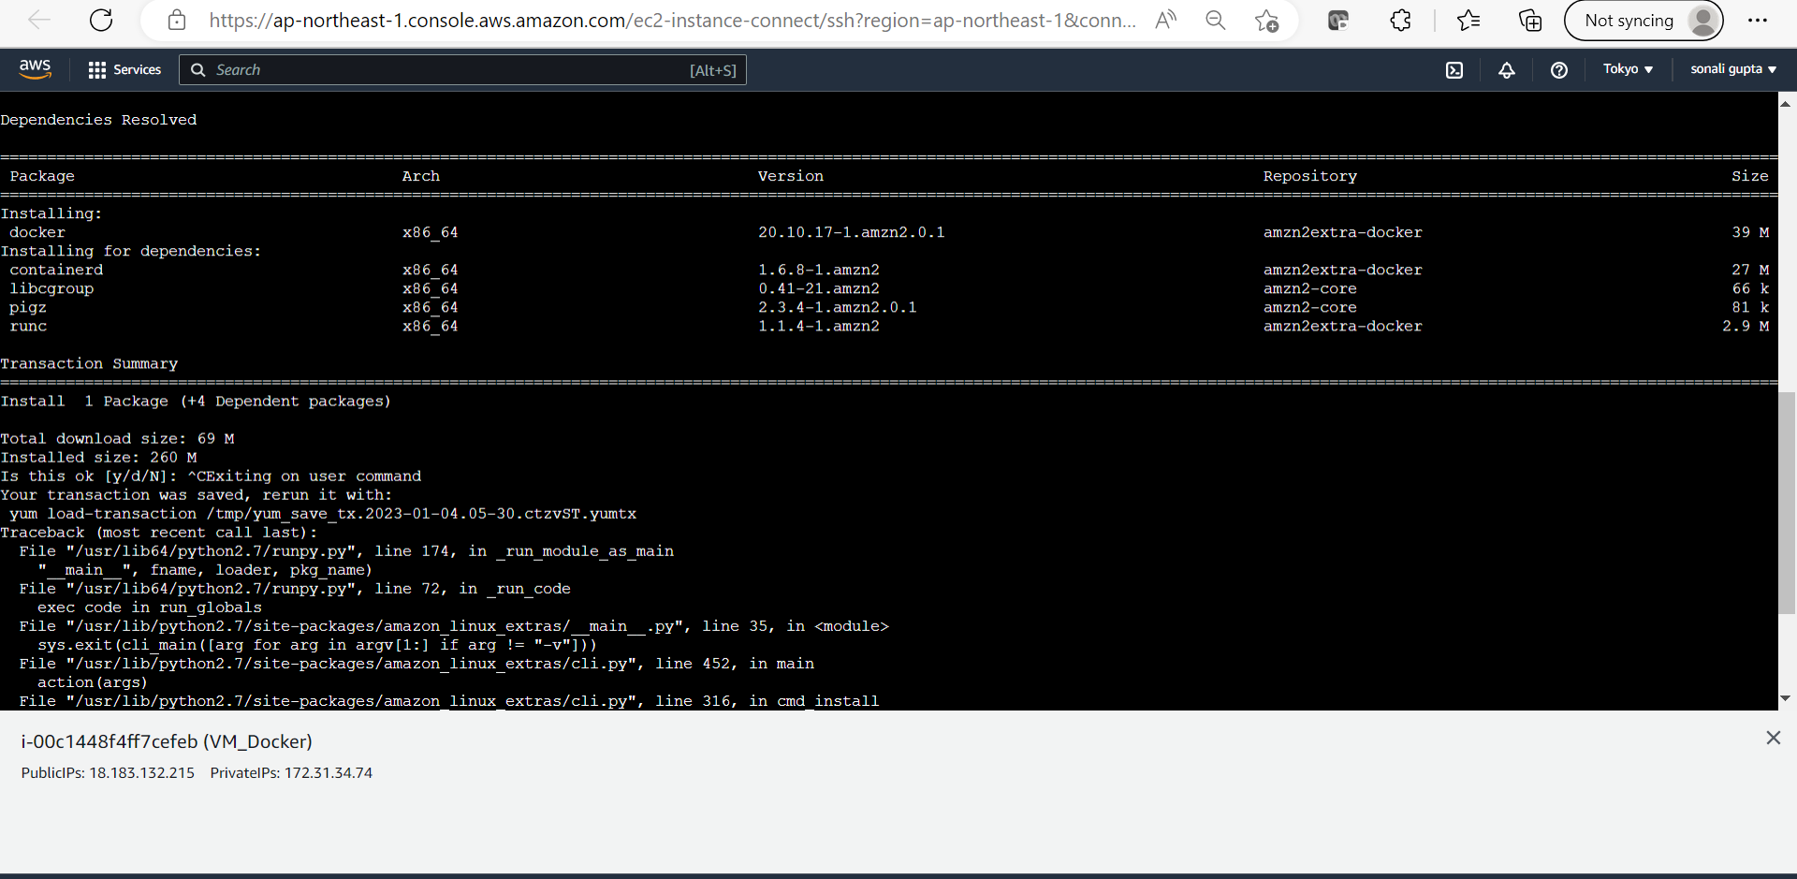

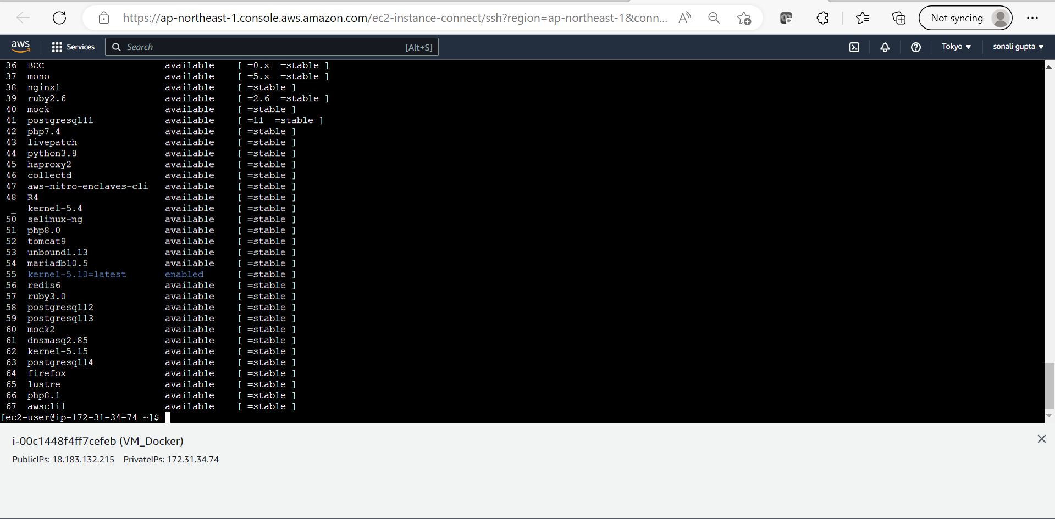

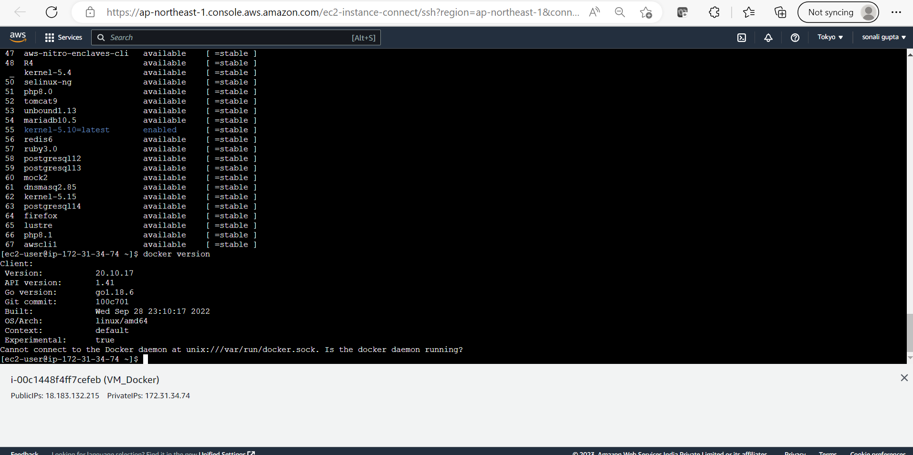

**2)sudo service docker start**

**sudo systemctl enable docker**

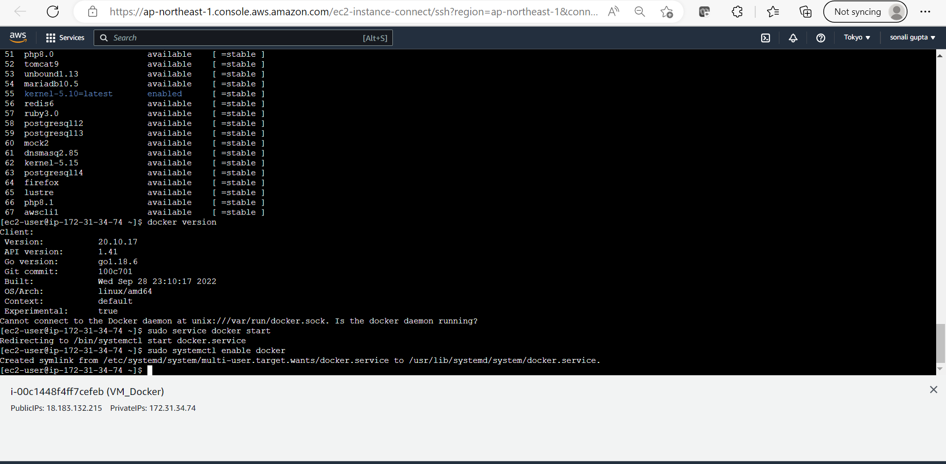

**Installing Ubuntu Image from the URL:** [**https://hub.docker.com**](https://hub.docker.com)

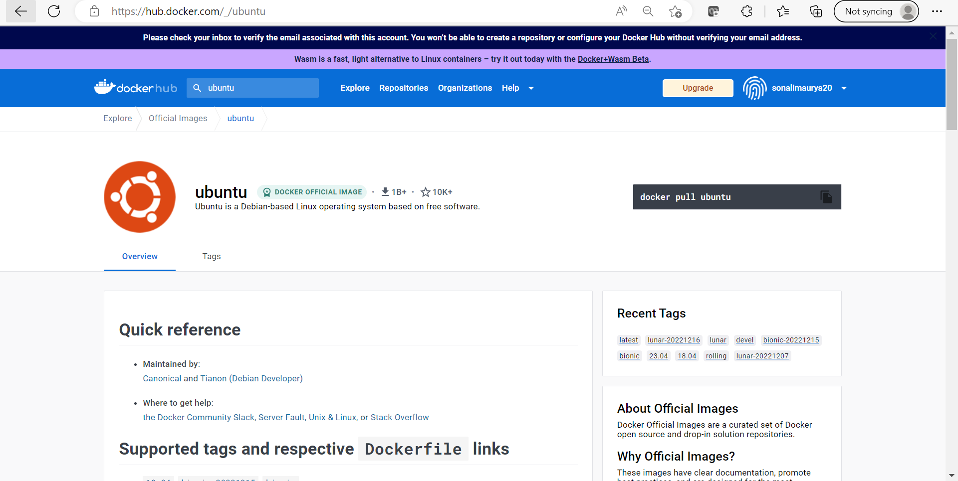

**Checking images**

Checking the Images

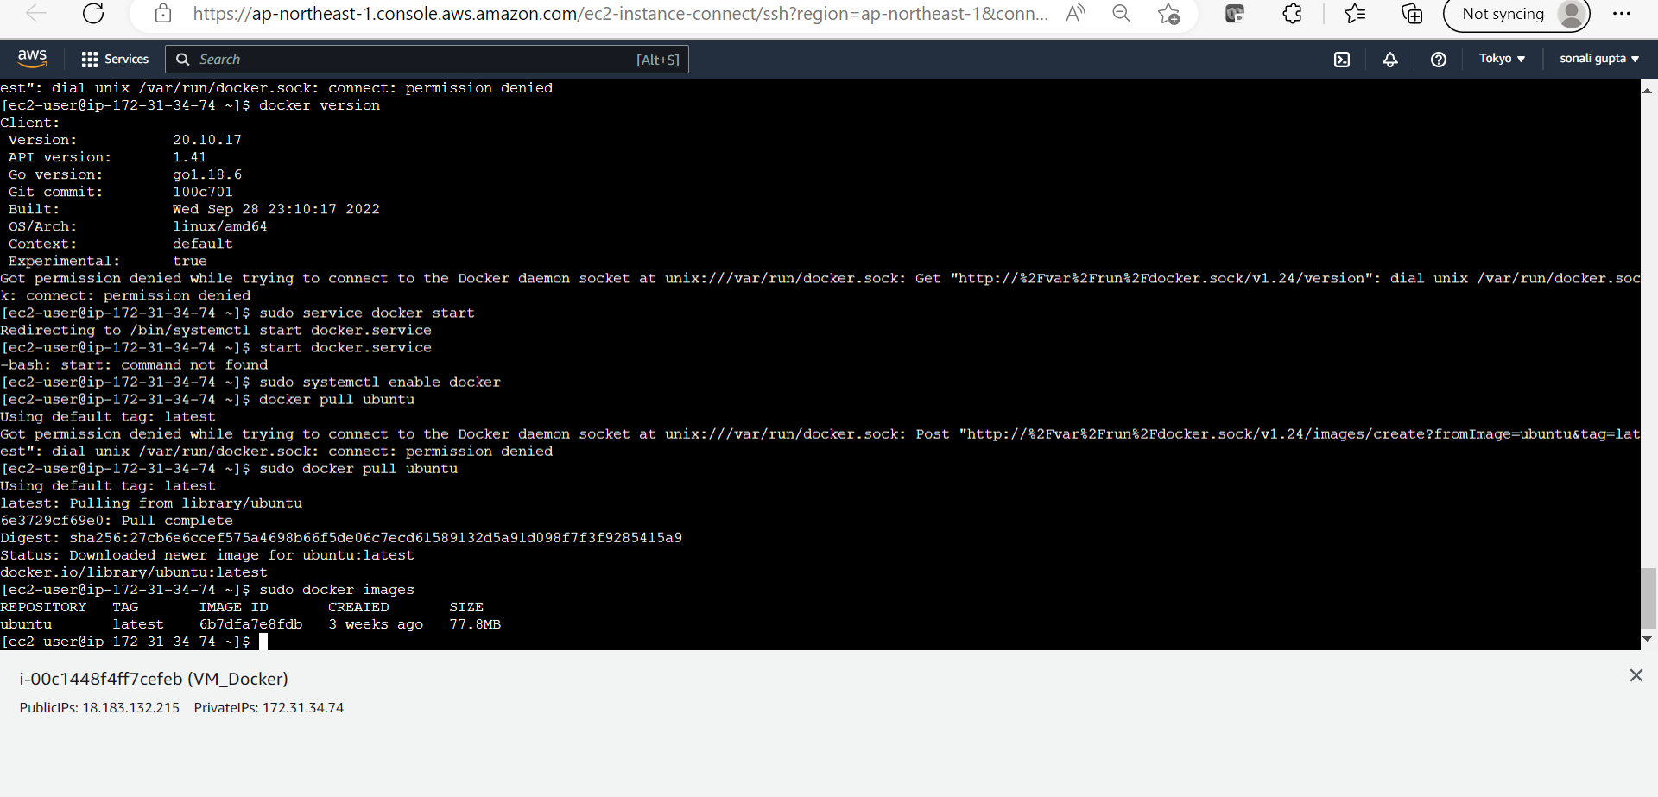

**Installing redis**

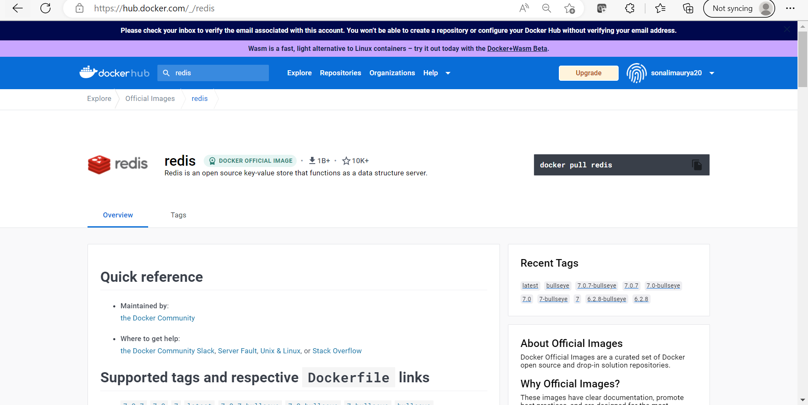

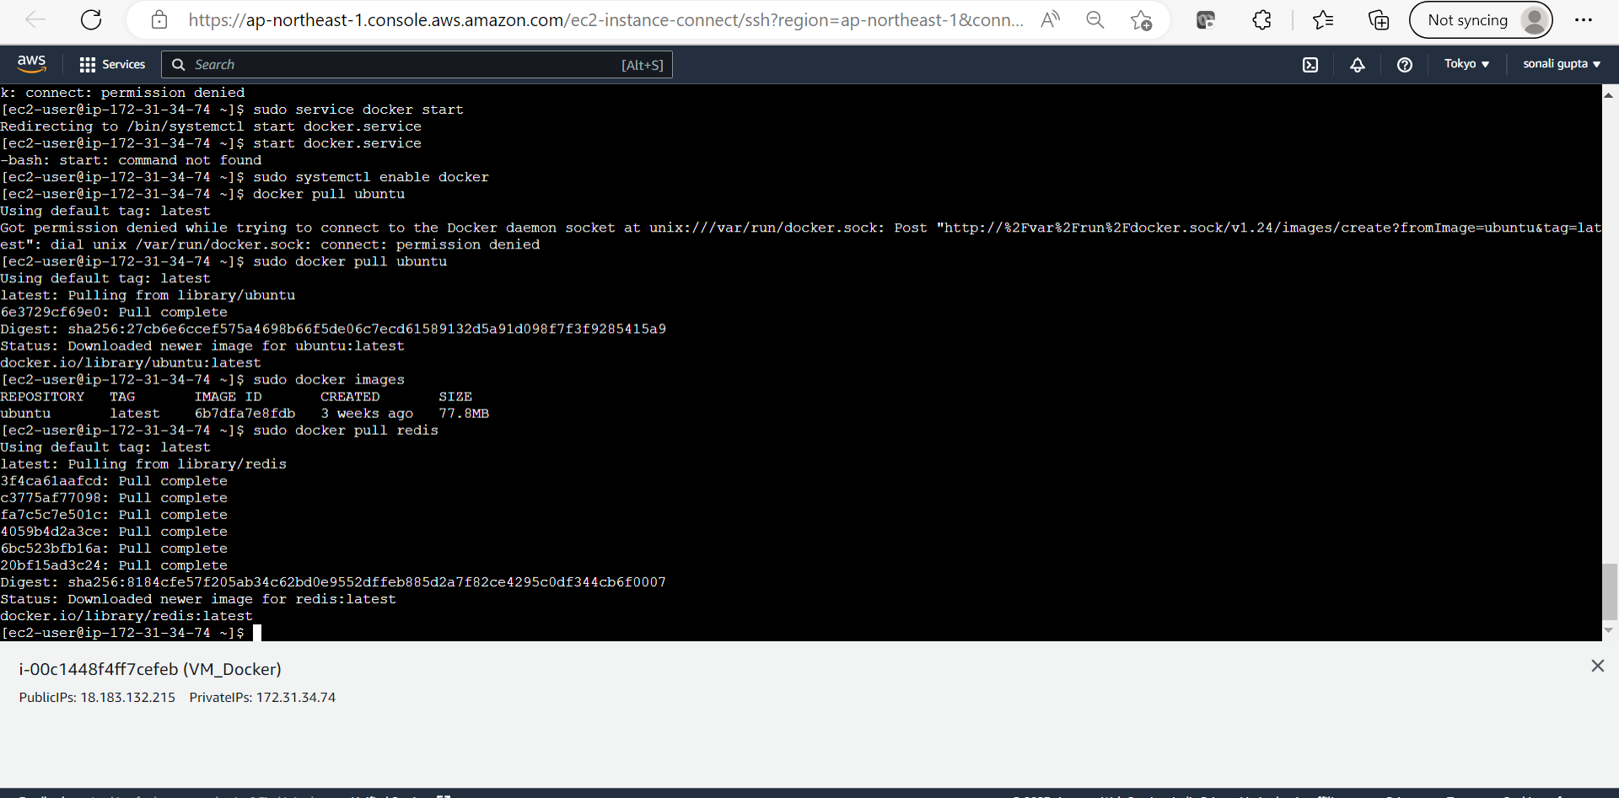

**Installing nginx**

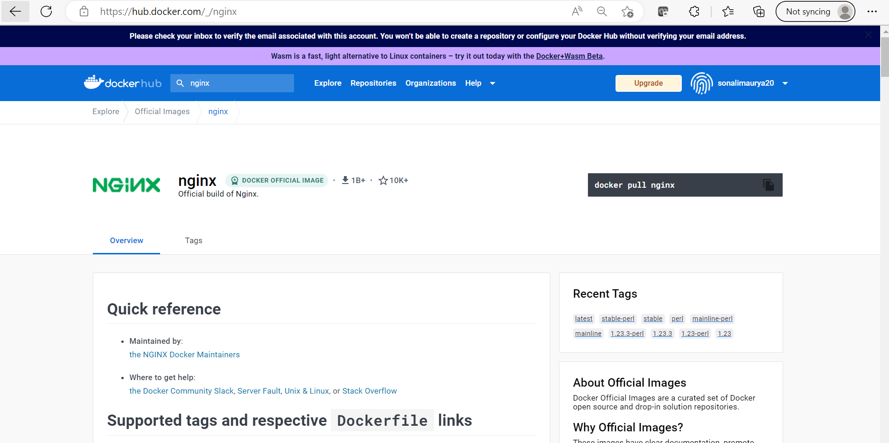

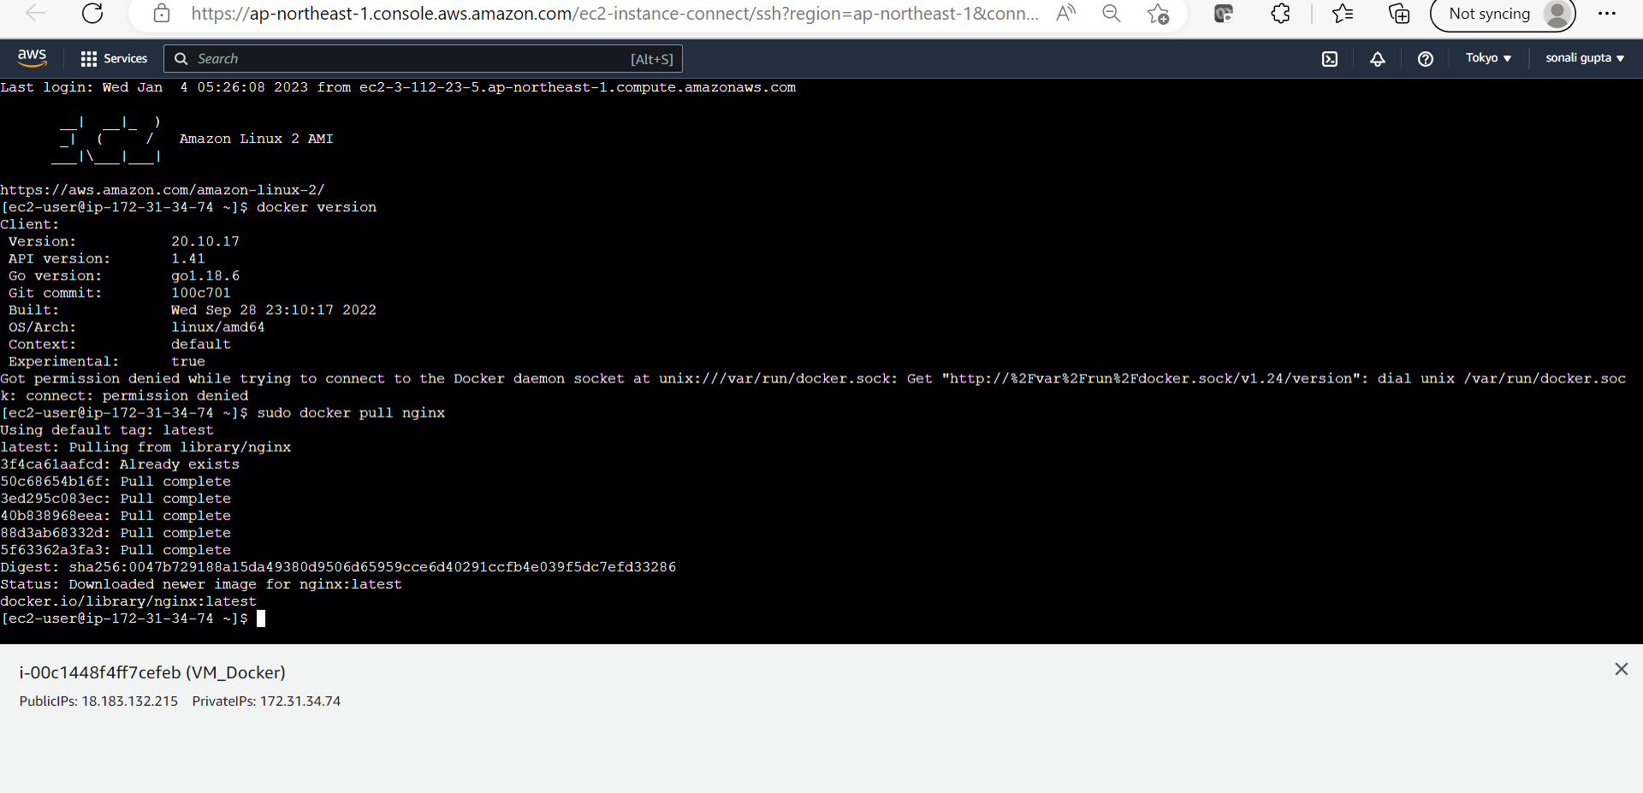

**Checking all created images**

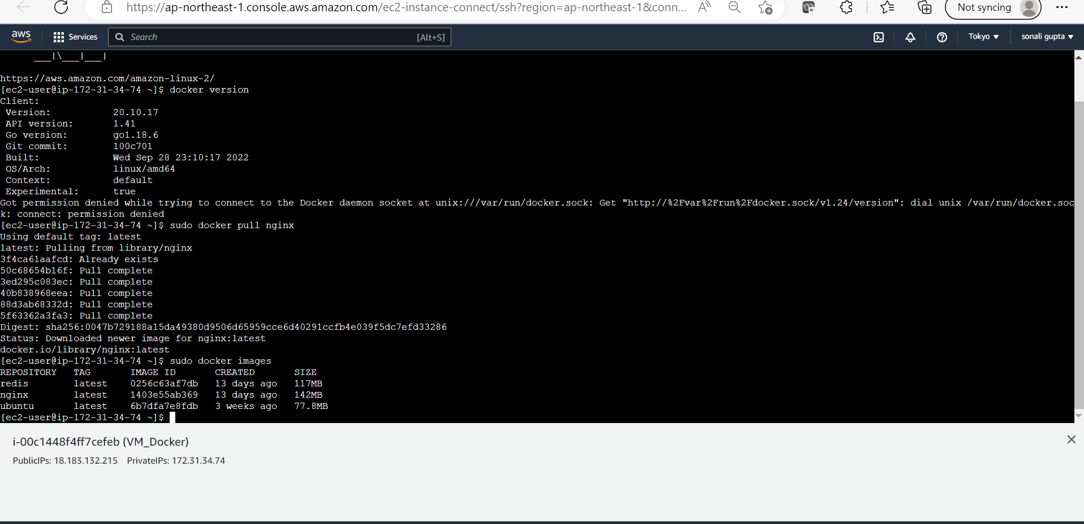

**Thus, Ubuntu, redis and nginx all three images have installed inside container.**

**Now running ubuntu inside**

**Container Commands 1) docker run -itd ubuntu (detached mode)**

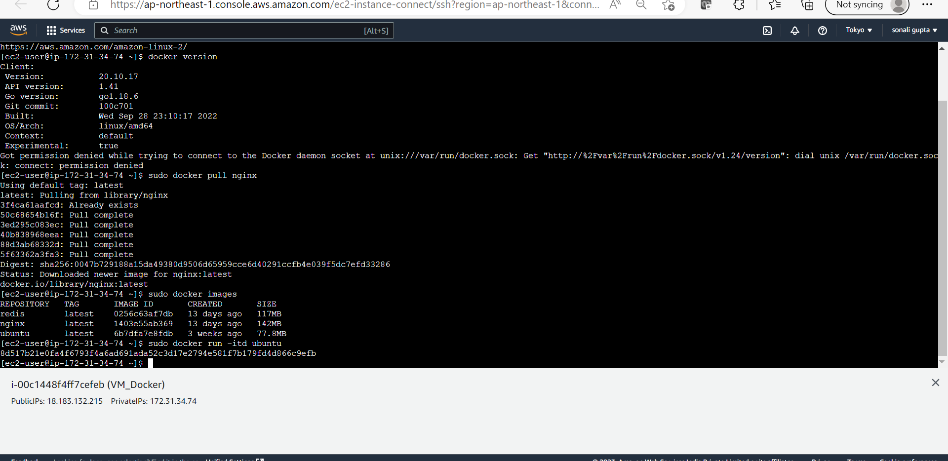

**2) Now checking ubuntu status inside container docker ps -a**

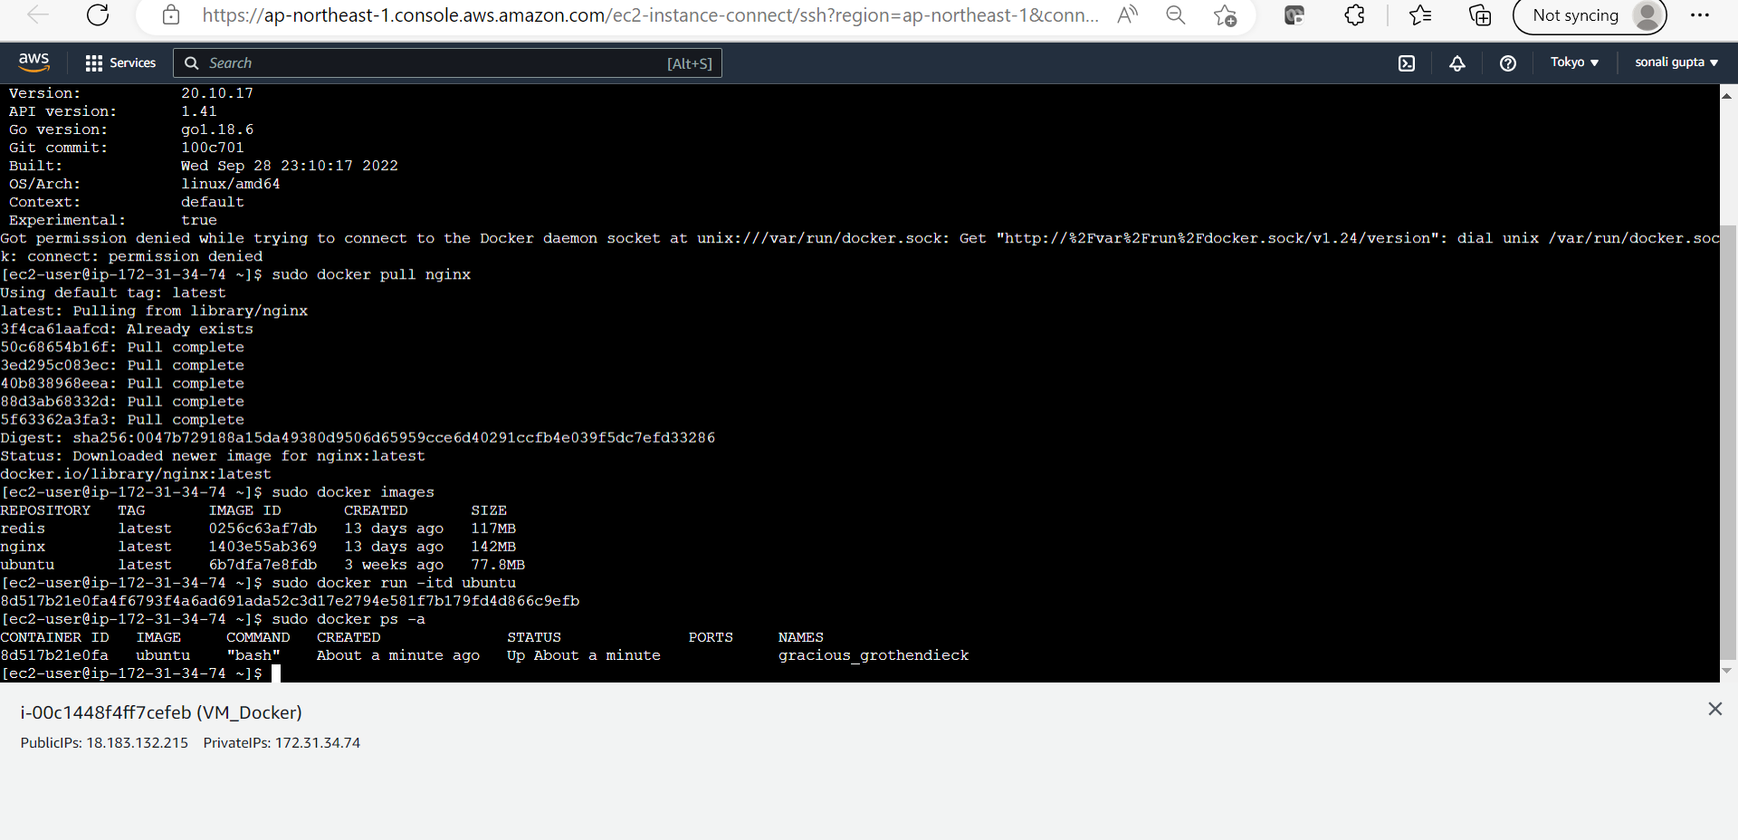 **Now running Nginx**

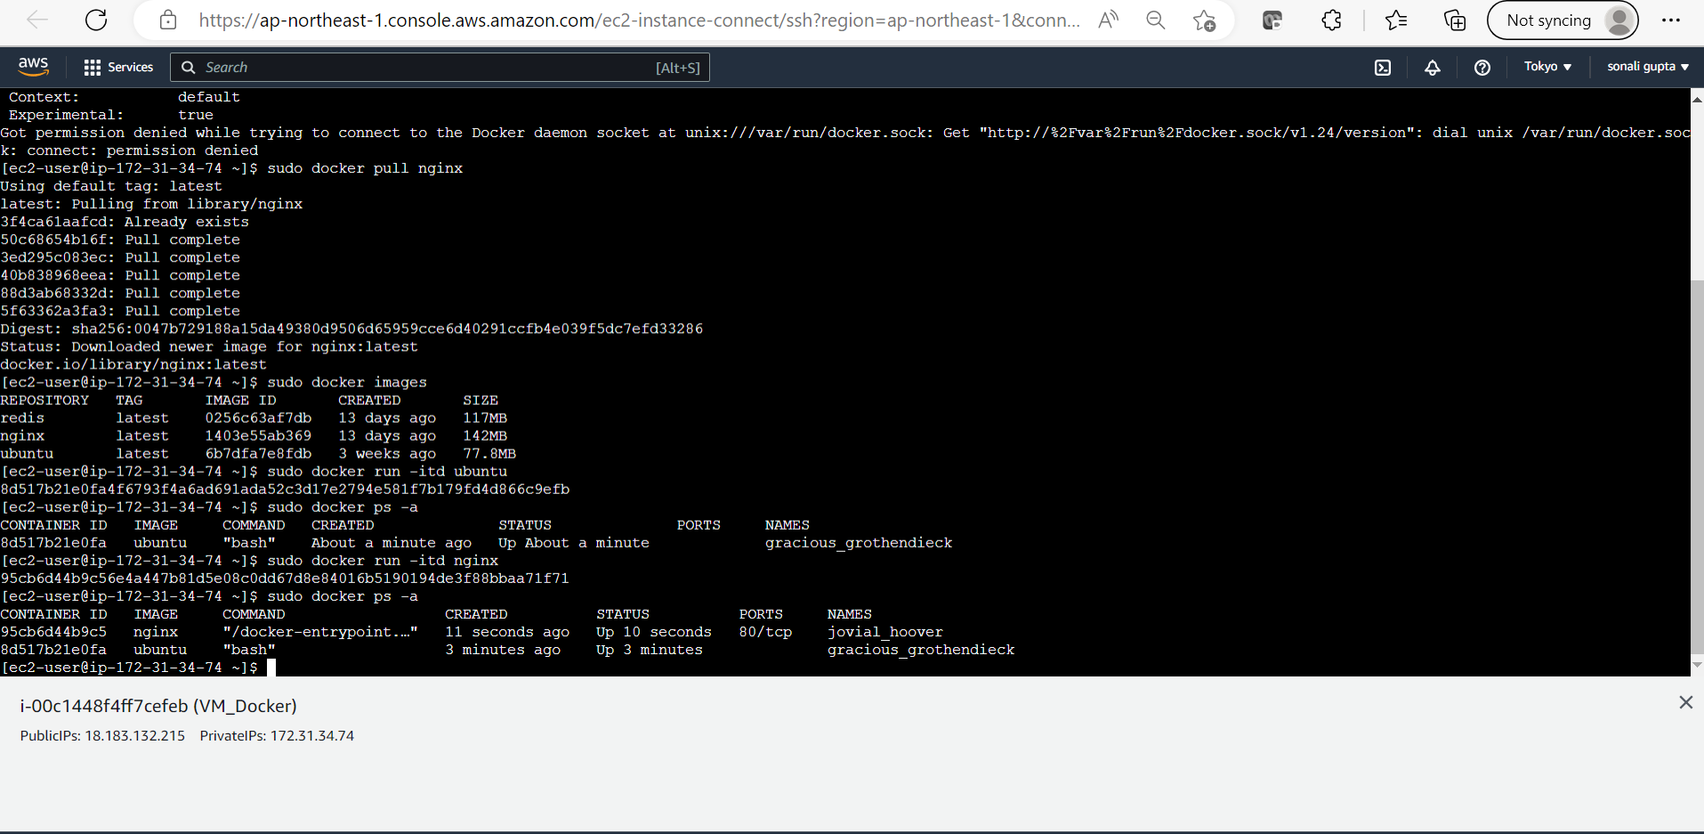

**Now running redis**

**And also all 3 images running inside the conatiner**

